Fellowship Report
Stiftung Hans Arp und Sophie Taeuber-Arp e.V.

Susanne Nørregård Nielsen, Glasgow School of Art

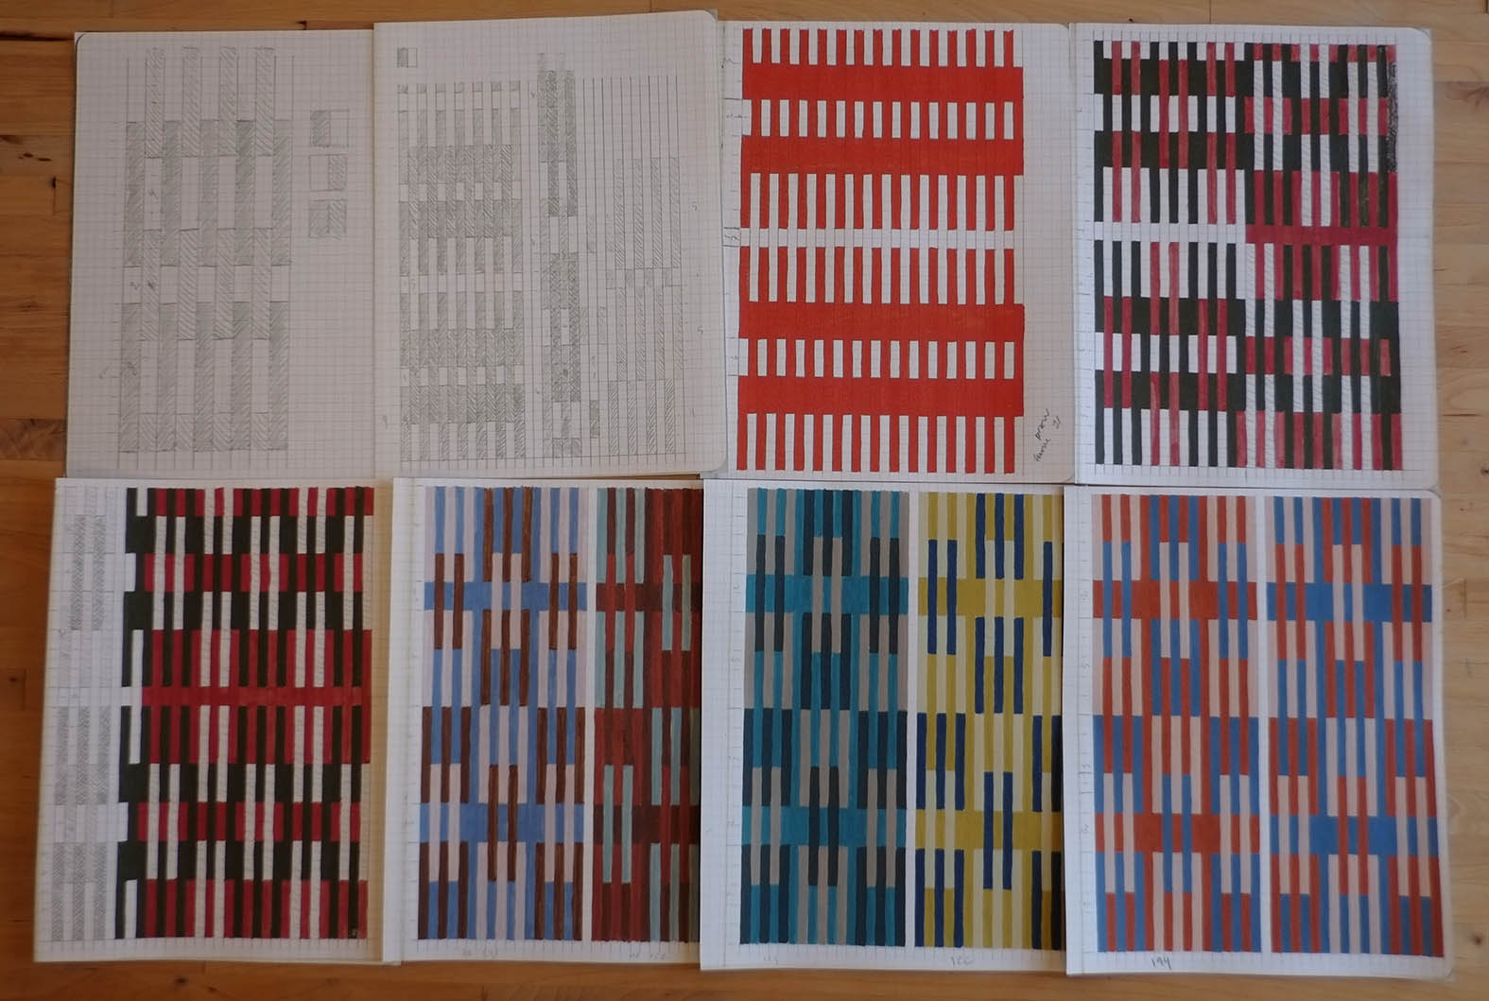
Preparatory work for drawing no. 1 and 2, Pencil and gouache on paper, 2019

‘Draw a square and try to divide it in its
most natural and simplest way, so that you
can use those forms or division lines as
decoration.
A further exercise is trying to divide it more
complex and paint the different fields with
two or three clear colours.’

Sophie Taeuber-Arp

During this year I have been working on getting a publicationtogether, which iscentred around Sophie Taeuber-Arp’s text ‘Remarks on Instruction in Ornamental Design’. The text was published in 1922 while she held a teaching post in Textile Design in the Department for Applied Art at the
Trade School Zürich from 1916 to 1929. In this text Taeuber-Arp sets out eight instructions for developing patterns and colour exercises.
The three main parts of the publication with the working title: ‘Draw a Square’ will consist of:
‘Remarks on Instruction in Ornamental Design’ by Sophie Taeuber-Arp, translated by Sarah
McGavran.
Coming from an art historian perspective; Walburga Krupp will write a text, working title: ‘Sophie Taeuber-Arp and her texts for the lessons at the Gewerbeschule Zürich’. The essay will be a short description of the two texts from 1922 and 1927 and try to research if there is any influence of her ideas on her pupils. On the basis of a selection of works by Blanche Gauchat, pupil and later on
co-author of the 1927 publication, Helen Guggenbühl, Rosa Löwy, Ida Störi, Rita Tröndle and Lucie Welti, and will examine if they followed the instructions of her teacher concerning composition and colour. Finally, it will be interesting to see if even Taeuber-Arp followed her own instructions.
During this year Walburga Krupp has made research visits to relatives of Sophie Taeuber-Arp pupils.
As an artist and practicebased researcher I set out to interpret and apply the instructions. This will accumulate in a visual essay as series of developing patterns in a sketch book (printed as sketch book pages in the publication).Please see a selection of drawings. I am interested in what new knowledge can we get through cognitive labour by following Sophie Taeuber-Arp’s instructions. The visual essay will be followed by a text on the experience and how the instructions works.
I will approach publishers in the new year.
For the first set of drawings following Sophie Taeuber-Arp instruction made in 2018I started dividing the square horizontal. For this publication I have divide the square vertical and the circle horizontal.

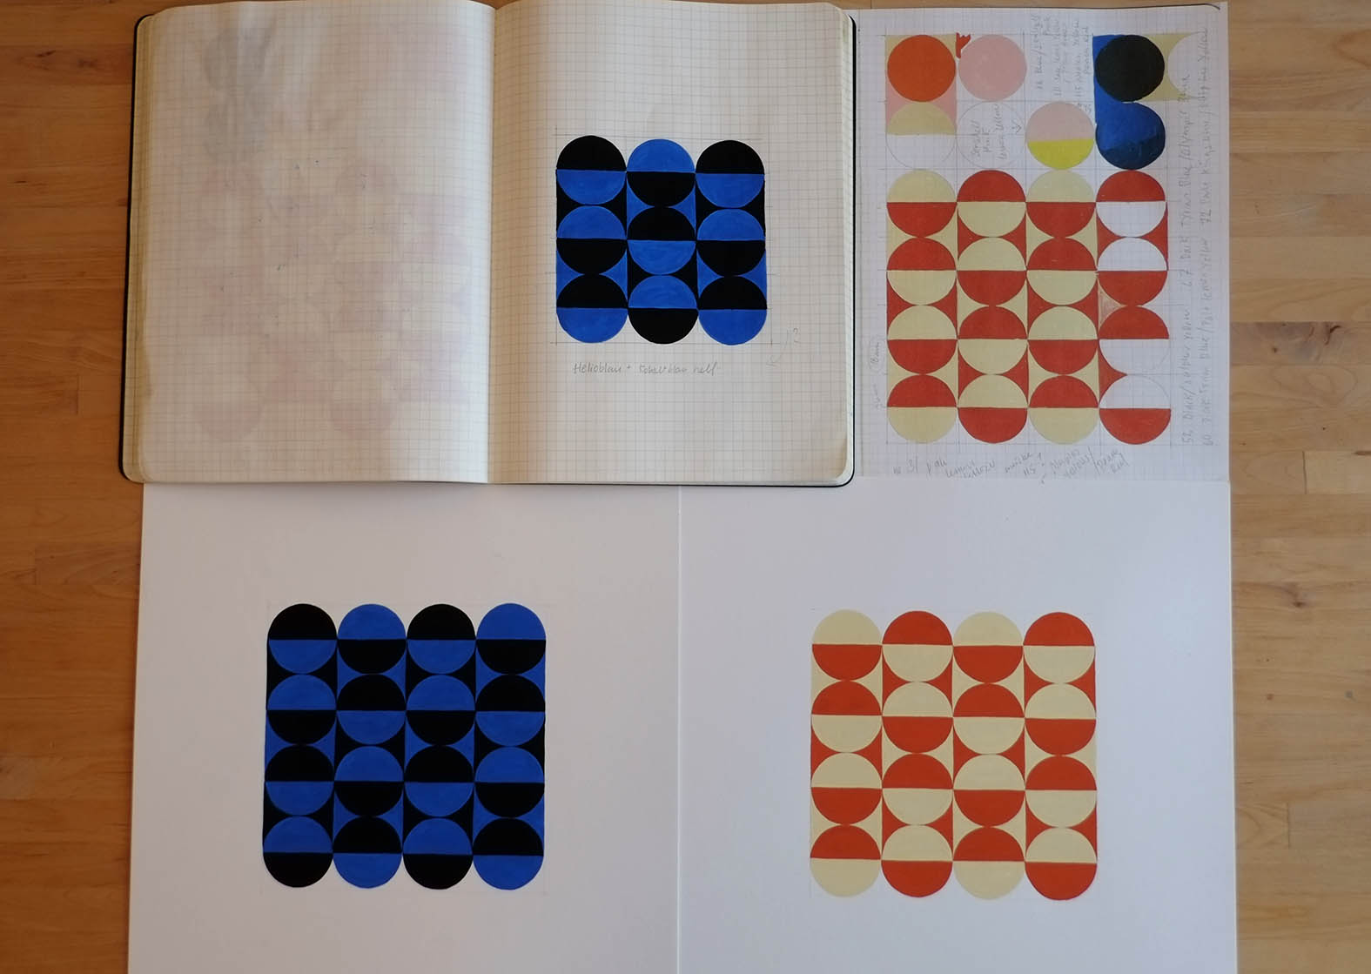
Preparatory work for drawing no. 4, Pencil and gouache on paper, 2019

‘Draw a square and try to divide it in its
most natural and simplest way, so that you
can use those forms or division lines as
decoration.
A further exercise is trying to divide it more
complex and paint the different fields with
two or three clear colours.
Sophie Taeuber-Arp

I would like to thanks the Stiftung and JanaTeuscher for the generous support during this Year.

Susanne Nørregård Nielsen
Glasgow School of Art

